CHAPTER 3
METHODOLOGY

Introduction
This chapter outlines the methodology employed in the design, development and evaluation of the PSM Assessment System. It describes the software process model selected for the project and justifies that choice, then sets out each phase of the model in the order it was carried out, together with the activities and deliverables of each phase. The chapter closes by mapping the project's objectives to the phases that satisfy them.

  - Prototype Model
The Prototyping model is a software process model in which a working version of the system is built early, shown to the client, and refined repeatedly until the client is satisfied. Unlike the Waterfall model, which follows a straight and sequential workflow where each phase is completed before the next begins, prototyping accepts that requirements become clear through use rather than through documentation alone, and it therefore plans for the initial design to be wrong (Chong Er Juan & Wahid, 2021). This model was selected for the PSM Assessment System because the administrative rules it must enforce are not stated anywhere in a form the developer can read. The official Lampiran forms fix the weightings and the marking scale, but the workflow around them exists only in the practice of the coordinator, and the faculty's own senior project reports describe the difficulties that arise when these working assumptions are never written down (Chong & Arbaiy, 2022; Nor Azim & Arbaiy, 2022). A prototype lets the coordinator see a proposed rule in operation and correct it, which is considerably cheaper than correcting it after a framework built on the wrong rule has been completed. Prototyping has been adopted for the same reason by comparable faculty systems, including the FSKTM supervision system and the assessment systems that followed it (Chong Er Juan & Wahid, 2021; Che Adnan & Hafit, 2025). This model is illustrated in Figure 3.1, and it consists of requirement gathering and analysis, quick design, building a prototype, client evaluation, refining the prototype, and implementation and maintenance.

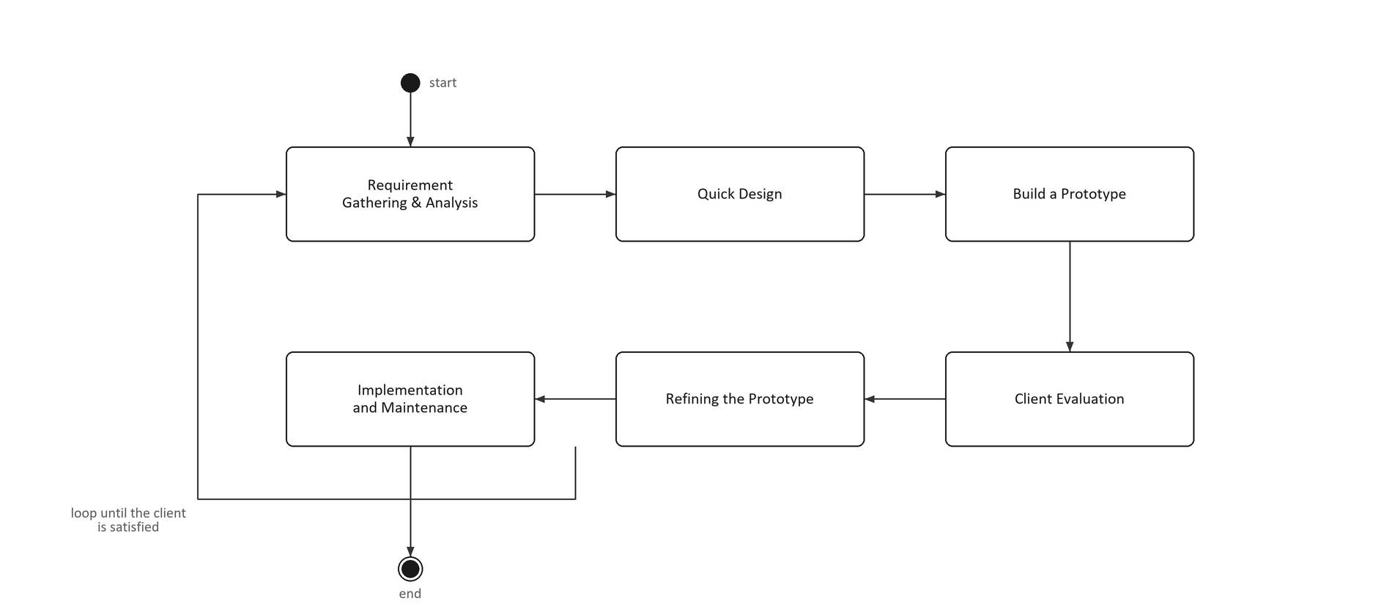
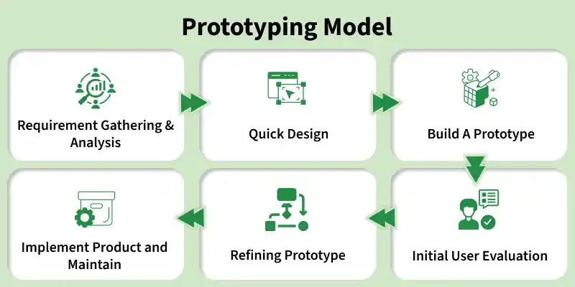
Figure 3.1 : Prototype model

      - Phase 1: Requirement Gathering and Analysis
This phase gathered the requirements of the PSM Assessment System from the official faculty forms, the faculty's PSM guide and the practice of the coordinator. The Lampiran A and Lampiran B forms established the registration fields, and the five assessment Lampiran established the rubrics, their item scales and their weightings (Universiti Tun Hussein Onn Malaysia, 2025). The phase also reviewed how comparable faculty systems handled the same domain, which identified the capabilities that the existing systems already provide and the ones they leave out (Arumugam & Abd Ishak, 2025; Wan Fauzi & Alduais, 2025). It established the functional and non-functional requirements necessary for the proposed system, which are recorded in Chapter 4. This phase directly supports Objective 1, which is to design the proposed system using the object oriented approach, by fixing the scope that the design has to cover.

      - Phase 2: Quick Design
This phase turned the requirements into a design that could be built and reviewed. The use cases were modelled, the domain classes were identified and the database schema was derived from them, so that every rule gathered in the first phase had a place in the design rather than a place in the developer's memory (Tam & Abdullah, 2025). The output of this phase is the class diagram, the data dictionary and the sequence and activity diagrams presented in Chapter 4. Together with Phase 1, this phase supports Objective 1 by laying the groundwork for a design that can be reviewed against the requirements before any code is written.

      - Phase 3: Build a Prototype
In this phase the proposed system was implemented as a working prototype. It was built as a decoupled web application, with a stateless Laravel application programming interface over a PostgreSQL database and a React single-page client, because that separation lets a rule change on the server reach every user without the client being rebuilt, and because the web based approach is the one the comparable faculty systems adopted (Arumugam & Abd Ishak, 2025; CIO Wiki, 2023). Access is controlled by role based access control, so a student, a supervisor, an examiner and a coordinator each hold different permissions over the same record (NIST, 2022). The prototype covered the six use cases specified in Chapter 4: login and authentication, manage title and registration, manage milestone, manage evaluation, generate report, and manage alert and notification. This phase directly supports Objective 2, which is to develop the proposed system using a web based approach for students, supervisors and coordinators.

      - Phase 4: Client Evaluation
The prototype was then demonstrated to its users and evaluated. The coordinator walked through the registration, milestone and term-close rules; supervisors reviewed the acknowledgement, the milestone decision and the evaluation form; and students worked through registration and submission. Each session was recorded against a checklist drawn from the requirements of Phase 1, and every rule that was disputed or found to be wrong was written down rather than corrected on the spot. Client evaluation is the step that makes prototyping worth its cost, because a rule that reads correctly in a specification can still be rejected by the person who has to apply it (Chong Er Juan & Wahid, 2021).

      - Phase 5: Refining the Prototype and Implementation
The findings of each evaluation were folded back into the prototype and the affected phases were repeated, which is the feedback loop shown in Figure 3.1. Where a rule had been modelled wrongly, the correction began at requirement gathering rather than at the screen, so the change reached the schema, the service and the interface together instead of being patched into the interface alone. This phase produced the system described in Chapter 5, and it is the phase that supports Objective 2 directly, because the requirements were refined by the users themselves rather than by the developer on their behalf.

Table 3.1: Mapping of Research Objectives with Evaluation Focus
Research Objective | Evaluation Focus
RO1: To design the proposed system using the object oriented approach | Correctness and completeness of the class, use case and database design
RO2: To develop the proposed system using a web based approach | Each of the six use cases working through the browser for its actor
RO3: To test the proposed system using User Acceptance Testing | Feedback from students, supervisors and the coordinator on the deployed system

To ensure alignment between methodology and evaluation, each research objective (RO) is mapped to a specific evaluation focus as shown in Table 3.1.

  - Chapter Summary
This chapter has presented the methodology adopted for the design and implementation of the proposed PSM Assessment System. The Prototyping model was selected because the administrative rules of PSM are held in the practice of the faculty rather than in a document, and prototyping is the process that allows those rules to be discovered and corrected by the people who apply them. The chapter set out the five phases carried out, from requirement gathering through to implementation and maintenance, and showed how the objectives of the project are satisfied by the phases. The next chapter presents the analysis and design produced by those phases.

